Herniated Disc and Sciatica Facts

Introduction
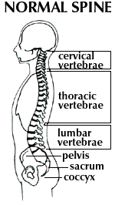
Herniated discs are probably the most common diagnosis for severe back pain and sciatica (leg pain). Discs are large cushions that lie between the individual vertebrae of our spinal columns.

The disc is composed of layers of ligaments (annulus fibrosis) arranged in a criss-crossing matrix that hold in a gel-like substance (nucleus pulposus), giving the disc its "shock-absorbing" ability. Sometimes the gel swells (which is called a disc protrusion or bulge).

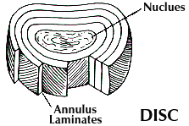 | 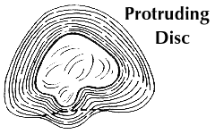

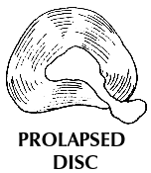
A more problematic situation occurs if the gel pushes through its ligamentous wall (which is a disc prolapse or extrusion). Both situations can led to pressure or irritation of the vulnerable spinal nerve roots. This can lead to sciatica - an abnormal sensation felt anywhere from the buttocks to the feet.
For more that 70 years, orthopedists have believed that most lower back pain and sciatica were caused by herniated discs. The "dynasty of the disc" led to the typical medical advice of bed rest and medication. Gordon Waddell, a renowned British orthopedic surgeon, wrote in the journal Spine, "There is remarkably little scientific or clinical evidence to support the value of bed rest for low back pain or even sciatica." Bed rest is now known to cause prolonged pain, muscle weakness, joint stiffness, and depression.
If bed rest failed, surgery was the usual next step. Unfortunately, due to poor patient selection, many unnecessary surgeries were performed. Waddell said, "surgical successes unfortunately only apply to approximately one percent of patients with low back pain." According to Alf Nachemson, M.D., editor of the journal Spine, bulging discs are found and taken as an excuse to do a lot of surgery and percutaneous discectomy. Discs are made to bulge; that is a normal finding."
Edward Carragee, M.D. the Dean of Neurosurgery at Stanford University reported that disc bulges are present even in 20 year olds, BUT by age 30 there are more episodes of back pain in individuals whose spines had no abnormalities when they were 20 than in those with the bulges! He has also written in the journal Spine that the long-term results of surgery vs. conservative care for pinched nerves is no different.
Back and even leg pain can arise from the muscles, joints, or ligamentous structures of the spine. Whatever the cause, evidence is growing showing that rehabilitation not surgery is the treatment of choice for most lower back disorders.

When should I see a doctor?
Anytime a person has pain radiating down their leg they should see a doctor to find out the reason why. This is not something urgent unless there is buckling of one or both legs, incapacitating pain, progressive pain or numbness, loss of bowel or bladder control, or numbness around the genitalia or anus.

Pain Control/First-Aid
Goal: reduce pain, swelling and inflammation
- physical therapy (e.g. ice, electrical muscle stimulation)
- manual therapy (e.g. massage, traction) and manipulation
- anti-inflammatory/pain medication if necessary

What can I do for myself?
An important study from a leading orthopedic center in San Francisco demonstrated that more than 90 percent of patients with disc herniations responded to non-surgical treatment. Most of these patients had already been referred by neurologists for immediate surgery. Their treatment included simple pain control methods in combination with rehabilitation. According to Nachemson, "All the structures in the back fare better with early, controlled motion....if something is injured and you start to slowly move it under controlled conditions, then the structure heals quicker and better."
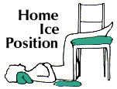
It is important to spare your spine if you have a pinched nerve. Slumping or bending forward from the waist are key sources of irritation of the disc. Prolonged sitting is another problem. Try not to sit for more than 20 minutes at a time without getting up and limbering your back. Because the disc is mostly water it swells at night when you are recumbent. Thus, the morning time is a critical time to keep your spine from bending forward while you brush your teeth, dry your feet and change.
Besides taking over-the-counter pain relievers of anti-inflammatories iceing your back at home is a key treatment. This can be performed for 20 minute intervals a few times a day.

Ways to increase your activity.
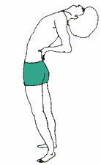
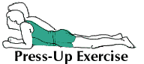
Walking is a safe exercise for pinched nerves due to herniated discs. If bending forward increases your leg symptoms, but bending backwards ONLY hurts in your back you may want to perform press-up and standing back extension exercises a few times a day. 10-12 slow repetitions are generally recommended. It is best to see a qualified health care provider to determine what exercise is best for you.

Rehabilitation
Goal: stabilize back through better flexibility, strength, and endurance
- education about lifting, sitting, etc.
- exercises to increase back and cardiovascular fitness
- encouragement to achieve and maintain a healthy back

