Abdominal Exercises Made Simple
Part 3 - Advanced Exercises
Once the basics of abdominal bracing and dying bug exercises are mastered curl-ups, side bridges, advanced dying bugs, and abdominal bracing in functional positions such as the squat are recommended. For each exercise perform 8–12 slow repetitions. This type of training should be performed twice a day.

Bicycle kicks on a foam roll
- Lie on your back on the foam roll.
- Bring your feet up in the air so that your shins are horizontal and your thighs vertical (90/90 position).
- Place both hands on the ground.
- Tighten your ‘‘core’’ by pushing your ribs down without flattening your lower back or holding your breath.
- Alternately kick your legs out like you are riding a bicycle (Figure 1).
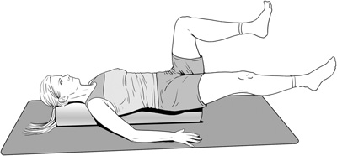

Dying bug on a foam roll
- Lie on your back on the foam roll.
- Bring your feet up in the air so that your shins are horizontal and your thighs vertical (90/90 position).
- Reach to the ceiling with one hand as high as you can while your other hand stays on the ground for support and balance.
- Tighten your ‘‘core’’ by pushing your ribs down without flattening your lower back or holding your breath.
- Tap a knee with the opposite hand (Figure 2a).
- Then extend your arm and leg on opposite sides (Figure 2b).
- Progress by adding a small medicine ball in your hand.
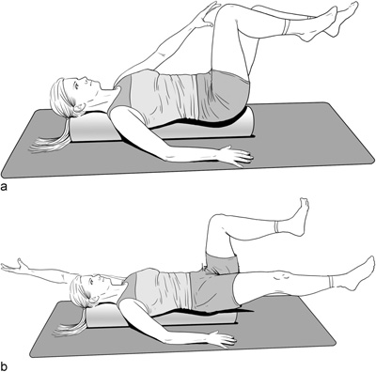

Wall slide squat
Lets transfer what you have learned on the floor and foam roll to an upright more functional activity such as squatting.
- Stand with your back against a wall.
- Raise your arms overhead bending them at the elbow so that the back of your hands touch the wall. J At the very least the thumb side of your hand should be on the wall.
- Move your feet a few inches forward of the wall and be sure the back of your head touches the wall as well.
- You should notice that your back arches somewhat.
- Tighten your ‘‘core’’ by pushing your ribs down without flattening your lower back or holding your breath (Figure 3a).
- Hold this abdominal brace and slide down the wall with your torso, but leaving your arms fixed.
- Your elbows should straighten (Figure 3b).
- Try to keep your back flat and ribs down in front while you slide up and down the wall.
